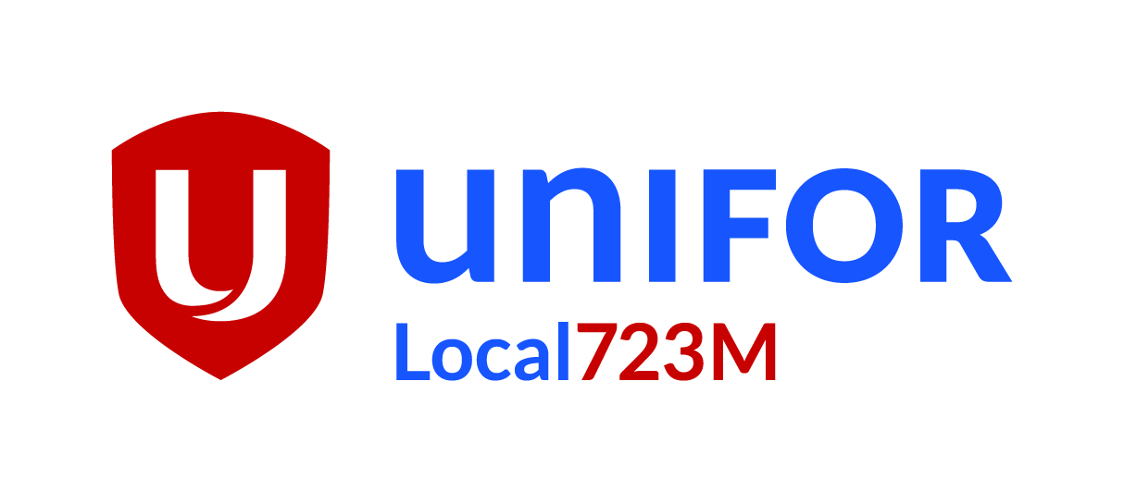

Agenda
UniforLocal723M
General Membership Meeting
December 6 & 7 , 2017

0:00 | Call to Order and minutes from last meeting
0:01 | Officers Reports

President – Angelo Contarin

Bell Media Unit – Michael Silva
Rogers City/OMNI Unit – Carl Davis
OMNI Production – RinaldoBoni

0:15 | Treasurer’s Report
 | Joshua Filipe
0:30 | Motions
0:45 | New Business
- Identification cards
- Holiday Vouchers
0:50 | Questions from the Floor
Open for members questions or concerns

Next Meeting 2018
1:00 | Motion to Adjourn

